**Prepare a Client-Server application in which client will send a request a string to make it in upper case.**

**Server.java**

1. import java.io.*;
2. import java.net.*;
3. public class server {
4. public static void main(String [] arg)
5. {
6. try
7. {
8. ServerSocket ss= new ServerSocket(777);
9. Socket s = ss.accept();
10. System.out.println("Connection Established..");
11. InputStream obj = s.getInputStream();
12. BufferedReader br = new BufferedReader(new InputStreamReader(obj));
13. String str=br.readLine();
14. System.out.println("Client String : "+str);
15. String str2=str.toUpperCase();
16. OutputStream os = s.getOutputStream();
17. PrintStream ps = new PrintStream(os);
18. ps.println(str2);
19. }
20. catch(IOException e)
21. {
22. System.out.println("Error : "+e.getMessage());
23. }
24. }
25. }

**Client.java**

1. import java.net.*;
2. import java.io.*;
3. public class client {
4. public static void main(String [] arg)
5. {
6. try
7. {
8. Socket s = new Socket("localhost",777);
9. BufferedReader br = new BufferedReader(new InputStreamReader(System.in));
10. String str;
11. System.out.println("Enter Stirng : ");
12. str=br.readLine();
13. OutputStream os = s.getOutputStream();
14. PrintStream pr = new PrintStream(os);
15. pr.println(str);
16. BufferedReader br2 = new BufferedReader(new InputStreamReader(s.getInputStream()));
17. String str2;
18. while((str2 = br2.readLine())!=null)
19. System.out.println("Server String : "+str2);
20. }
21. catch(IOException i)
22. {
23. System.out.println("Error : "+i.getMessage());
24. }
25. }
26. }

**OUTPUT**

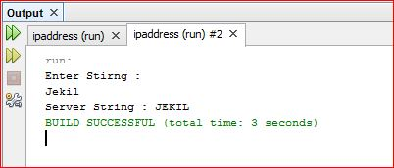

**Client**

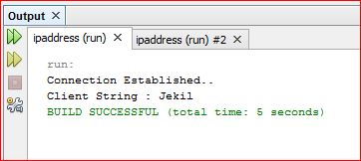

**Server**